Chic, Alors!
French kit on clothing
Unit Learning Goal
- Students can identify letters of the alphabet and phonemes in French
- Students can identify colours and describe clothing for a fashion show
- Students can tell which clothes they wear (porter), use verbs to have (avoir) in sentences

Day 1 (45 min): Alphabet and vocabulary focus
Greeting: Bonjour/ Salut, Comment ça va? Comment t’appelles-tu?
- Play Bonjour song (Alain le lait) https://youtu.be/atNkI6QFZ50
Pronunciation – sorting new vocabulary (clothing – les vêtements
- Alphabet & pronunciation of vowels (go through letters of the alphabet together with the class (Can play embedded Alain le Lait “l’alphabet en français - )
- Hangman: Letters of the alphabet practice (review letters en français) – students use these phrases to guess the word
Est-ce qu’il y a un …? (Is there a V? Is there an V?)
Est-ce que c’est? (Est-ce que c’est un VESTE? Is it a vest?)
Clothing vocabulary (2 sets) – have students guess English words and then share the rest – put the tie into the shirt to reveal the correct words
SMART Board games -
- Match French sport word to image (click on blue rectangle to expand picture) and have students say the word as they complete the pairs
- Exit ticket: Have students answer the question: Qu’est-ce que tu portes? (what are you wearing?)
  - Answer: Je porte un T-shirt.

Day 2 (45 min): Le Verbe Porter
- 2 min demo intro: Model actions and have students guess what’s happening (eating, drinking, dancing, singing) – explain that verbs are action words and are critical in communication and sentence structure.
- Present pages on Les Verbes - “porter”
- Practice conjugating “porter”:
  - SMART Board game – Conjugate Porter (option for students to get a device and click on « device icon » to project code for students to enter www.hellosmart.com and practice game separately or at device stations). Students drag the pronoun to match the verb conjugation and say the pair together
  - Making sentences – student rolls die on SMART Board and conjugate “Porter” and create a sentence (e.g., Je porte une chemise bleue.)
  - SMART Board game –Porter means “to wear” and apporter means “to bring”. Students sort the words to the “wearing = porter” or “bringing = apporter” category. Students can then make a sentence using a proper conjugation of (ap)porter (e.g., J’apporte un livre.)
- Conversation activity prompts: “Le Temps et les vêtements 2” in partners, students can build and practice these scripts in a conversation.
- Matching exercise: students draw lines to match the clothing with the French word.

Day 3 (45 min): Reflexive Verbs
- Present page on le reflexive verbs
- Play song (https://youtu.be/HqvL_ZdOAxs)
- TPR (Total physical response) - use commands in French for students to pretend carrying out actions (levez-vous = stand up, assoyez-vous = sit down, lavez-vous = wash up, habillez-vous = dress yourself, etc.) This could become a game of Simon says (Simon dit…)
- Practice conjugating “reflexive verbs”:
  - SMART Board game – Match image with reflexive verb (option for students to get a device and click on « device icon » to project code for students to enter www.hellosmart.com and practice game separately or at device stations). Students drag the conjugation to match the image and say the pair together
- Reflexive verb worksheets: students complete the reflexive verb conjugations, remembering the reflexive pronouns (je me, tu te, il/on/elle se, nous nous, vous vous, ils or ells se)

Day 4 (45 min): Verb « avoir », weather & colour
- Present page on conjugation of avoir (to have)
- Play song (https://youtu.be/MnUWNIN3zss ) - or sing avoir to the tune of the ants go marching
- Practice conjugating “avoir”:
  - SMART Board game – Match pronoun with the correct conjugation of avoir (option for students to get a device and click on « device icon » to project code for students to enter www.hellosmart.com and practice game separately or at device stations).
- Go over colours in French (https://youtu.be/-4kNeFGBAcw song is catchy too!). Like most adjectives in French, colours go after the noun. For feminine nouns, colours need to have an “e” added to the end (e.g., la table brune…la chaise blanche). For plural nouns, “s” needs to be added to the end (e.g., les pupitres bleus, les chaises blanches)
- Weather (La météo)!
  - SMART Board game – Match the image with the weather phrase (option for students to get a device and click on « device icon » to project code for students to enter www.hellosmart.com and practice game separately or at device stations).
  - Slide weather pictures and phrases to the sentence structure, “Quand…, je porte … Have students create and read the sentences.
- Colour agreement worksheets: students complete worksheets adding colours after the noun, checking for agreement with gender and number
- Drawing/ colouring exercise: students draw and colour clothing onto the 4 pictures based on the descriptions given

Day 5 (45 min): Story
Story read-aloud: Chic, Alors!
- Pre-reading: Ask students what the story might be about based on front cover and the climax-building page (page 5). Students need to attend to any clues that they see!
  - Qu’est-ce que vous observez? (What do you see/ notice?)
  - Qu’est-ce qui se passe? (What’s happening?)
  - Qu’est-ce qui va se passer après ça? (What’s will happen next?)
- Reading: Project the story from https://aquilaonlinebooks.com/ (Sign in with Username: 12296 Password: xr27w2 and go to “My Videos” and scroll down to Aquila Bandes-Dessinées “Chic, Alors!” Click the play button and choose “Lexique” to enable French-English dictionary for the read-aloud text. Students watch the video or follow along with the student anthologies. Click cog for slower speed (0.75x) pause/ repeat as needed.
- Print “Lexique sheets” for students to look over vocabulary

Replay story as needed. Students use the student booklets as a review of the information and refer to the glossary at the end of the story. Pass out BLM Activities/ worksheets: Chic, Alors! To be completed as a review of the unit.

Day 6 (45 min): Presentations & Assessment (* Give students forewarning about the upcoming fashion show and that students should be looking for an outfit/ costume for this purpose. For more focused, preparation and presentation quality, more lessons may be needed for students to rehearse and prepare for the presentation)
Have students draw the articles of clothes that they will present in a fashion show (hand-out “la tenue” and “script: un defile de mode” for students to design and explain their outfits) . Show students exemplars of outfits and scripts from “vêtements project” & “défilé de mode”

Students in partners explain the other student’s outfit using the script. Model how to speak clearly and loudly and with gestures.

Presentation (with clear voice)
Self-assessments: Choice of rubric or single point rubrics on:
- Introducing self/others and participation
- Pronunciation and participation
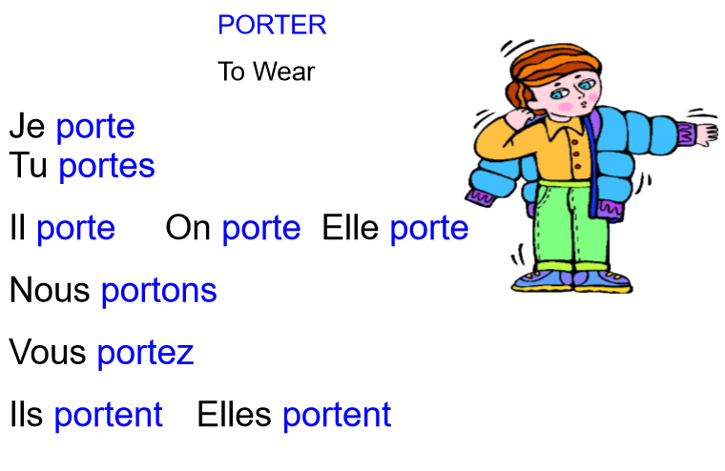

Qu’est-ce que tu portes?
Je porte une chemise brune.

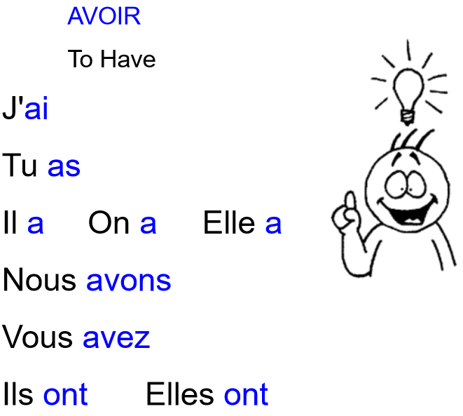

Qu’est-ce que tu as?
J’ai des bottes noires.
Nom: _________________ French speaking rubric Date: _________________
 | Emerging | Developing | Proficient | Extending
Support needed | The student pronounces only with constant teacher support, in highly structured situations. | The student pronounces with frequent teacher support, in structured situations. | The student pronounces with occasional teacher support, in structured and open-ended situations. | The student pronounces with little or no teacher support, in structured and open-ended situations.
Range of vocabulary | The student pronounces using a few basic forms, structures and vocabulary. | The student pronounces using some basic forms, structures and vocabulary. | The student pronounces using most basic forms, structures and vocabulary. | The student pronounces using all or almost all basic forms, structures and vocabulary.
Je peux parler en français! I can speak French!

- I can say all letters of the French alphabet.
- I can introduce myself or someone else.
- I can describe others with simple sentences in French.
- I can describe people and things.

Nom: _________________ French speaking rubric Date: _________________
 | Emerging | Developing | Proficient | Extending
Support needed | The student pronounces only with constant teacher support, in highly structured situations. | The student pronounces with frequent teacher support, in structured situations. | The student pronounces with occasional teacher support, in structured and open-ended situations. | The student pronounces with little or no teacher support, in structured and open-ended situations.
Range of vocabulary | The student pronounces using a few basic forms, structures and vocabulary. | The student pronounces using some basic forms, structures and vocabulary. | The student pronounces using most basic forms, structures and vocabulary. | The student pronounces using all or almost all basic forms, structures and vocabulary.
Je peux parler en français! I can speak French!

- I can say all letters of the French alphabet.
- I can introduce myself or someone else.
- I can describe others with simple sentences in French.
- I can describe people and things.

