Salut Alfred!
French kit on basics
Unit Learning Goal
- Students can identify letters of the alphabet and phonemes in French; count numbers 1-20
- Students can use common questions, greetings and introductions
- Students can tell which animals they like (aimer) or don’t like (ne pas aimer)

Day 1 (45 min): Alphabet and number focus
Greeting: Bonjour/ Salut, Comment ça va? Comment t’appelles-tu?
- Play Bonjour song (Alain le lait) https://youtu.be/atNkI6QFZ50
Pronunciation – sorting new vocabulary (les animaux and other words)
- Alphabet & pronunciation of vowels (go through letters of the alphabet together with the class (Can play embedded Alain le Lait “l’alphabet en français)
- Hangman: Letters of the alphabet practice (review letters en français) – students use these phrases to guess the word
Est-ce qu’il y a un …? (Is there a B? Is there an O?)
Est-ce que c’est? (Est-ce que c’est un OISEAU? Is it a bird?)
Numbers : counting practice
- Play embedded video (Alain le Lait counting to 20) https://youtu.be/atNkI6QFZ50
- Hide an object (e.g., Hugo le chien or another stuffed animal) when a chosen student is in hallway. Class need to count 1 to 20 over and over but with higher or lower volume to indicate hotter or colder to help guide the student to discover the object
SMART Board game – “Comment ça va?”
Pair & share – students partner and practice
- Model with the stuffed animal how to introduce yourself
  - Bonjour, je m’appelle … Comment t’appelles-tu? Moi, je m’appelle…
- Guided practice with other students
- Students practice with “Les Salutations/ Introducing Yourself” sheet
Day 2 (45 min): Animals and introductions
Greeting: Bonjour/ Salut, Comment ça va? Comment t’appelles-tu?
- Play Bonjour Monsieur, Comment ça va (Maxwell) https://youtu.be/atNkI6QFZ50
- Model Comment ça va? with expressions; Students complete Comment ça va icebreaker activity
Animal vocabulary (SMART Board game)
- Show visual: Voici un/ une … (student repeat).
- J’ai un chien (I have a dog)/ je n’ai pas de chien. (Introduce the verb avoir (to have) & negative)
Story read-aloud: Salut Alfred!
- Pre-reading: Ask students what the story might be about based on front cover and the climax-building page (page 5). Students need to attend to any clues that they see!
  - Qu’est-ce que tu observes? (What do you see/ notice?)
  - Qu’est-ce qui est dans la boîte? (What’s in the box?
  - Qu’est-ce qui se passe? (What’s happening?)
  - Qu’est-ce qui va se passer après ça? (What’s will happen next?)
- Reading: Project the story from https://aquilaonlinebooks.com/ (Sign in with Username: 12296 Password: xr27w2 and go to “My Videos” and scroll down to Aquila Bandes-Dessinées “Salut Alfred!” Click the play button and choose “Lexique” to enable French-English dictionary for the read-aloud text. Students watch the video or follow along with the student anthologies. Click cog for slower speed (0.75x) pause/ repeat as needed.
Pair & share – students partner and practice
- Students complete activity worksheet on finding out how many pets each other has
Day 3 (45 min): Review & practice

Greeting: Bonjour/ Salut, Comment ça va? Comment t’appelles-tu?

Animal vocabulary: Voici un/ une/ deux/ trois …

SMART Board sorting games: choice of:
- Comment ca va?
- Comment s’appelle-t-il?
- Qu’est que c’est?

Story read-aloud/ reader’s theatre: Salut Alfred!
- Reading: Project the story from https://aquilaonlinebooks.com/ (Sign in with Username: 12296 Password: xr27w2 and go to “My Videos” and scroll down to Aquila Bandes-Dessinées “Salut Alfred!” Click the play button and choose “Lexique” to enable French-English dictionary for the read-aloud text. Students can watch the video or follow along with the student anthologies. The story is read quickly but click on the cog to slow its speed (0.75x). Pause the story, check for understanding and repeat the read-aloud as needed.
- Choral reading practice (together)
- Practice with a partner or skit activity practice (groups of 5)
Learn & practice aimer (to like) – show conjugation and play song

Exit ticket – Quel animal est-ce que tu aimes? Make a sentence: J’aime … J’adore…. Je n’aime pas… choice of animals

Days 4-5 (45 min): Presentations & Assessment (* for more focused, preparation and presentation quality, more lessons may be needed for students to rehearse, gather props and present the reader’s theatre)

Model how to add dramatic/ emotional effect, gestures, and some options for changing the dialogue

Options to adapt the skit:
- Reduced story script (page 10-12 only) requires only 3 students (Sylvie, Marcel & André), fewer lines
- Use the script (Skit: Nos animaux) and have students create their own story
- For students needed extra challenge, the receptionist has the most lines

Presentations (Day 4 or 5): skit presentations (with dramatic effect)

Self-assessments: Choice of rubric or single point rubrics on:
- Skit and presentation and participation
- Pronunciation and participation

BLM Activities/ worksheets: Salut, Alfred! To be completed as a review of the unit

AVOIR = to have
J’ | ai
Tu | as
Il (elle) | a
Nous | avons
Vous | avez
Ils (elles) | ont
Qu’est-ce que tu as?
J’ai un chat. Je n’ai pas de serpents.

AIMER = to like
J’ | aime
Tu | aimes
Il (elle) | aime
Nous | aimons
Vous | aimez
Ils (elles) | aiment
Quel animal est-ce que tu aimes?
J’aime les chats .

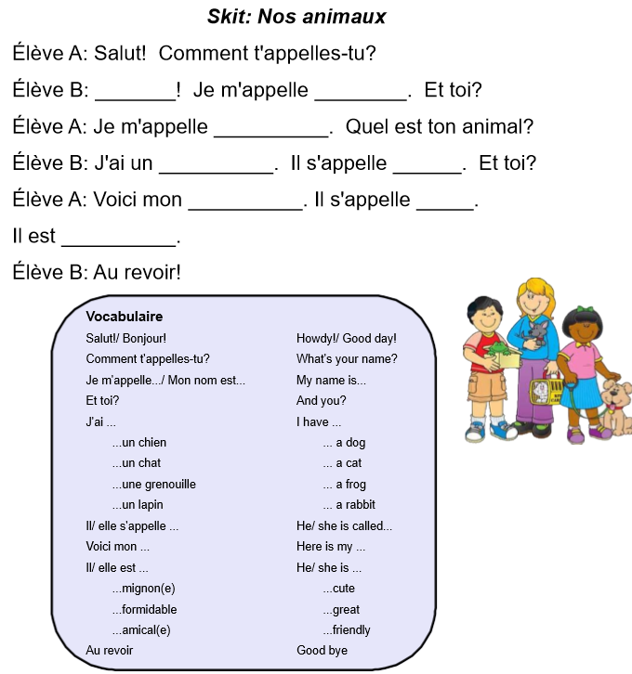
Nom: _________________ French speaking rubric Date: _________________
 | Emerging | Developing | Proficient | Extending
Support needed | The student pronounces only with constant teacher support, in highly structured situations. | The student pronounces with frequent teacher support, in structured situations. | The student pronounces with occasional teacher support, in structured and open-ended situations. | The student pronounces with little or no teacher support, in structured and open-ended situations.
Range of vocabulary | The student pronounces using a few basic forms, structures and vocabulary. | The student pronounces using some basic forms, structures and vocabulary. | The student pronounces using most basic forms, structures and vocabulary. | The student pronounces using all or almost all basic forms, structures and vocabulary.
Je peux parler en français! I can speak French!

- I can say all letters of the French alphabet.
- I can say French vowel sounds correctly.
- I can count numbers 1-20.

Nom: _________________ French speaking rubric Date: _________________
 | Emerging | Developing | Proficient | Extending
Support needed | The student pronounces only with constant teacher support, in highly structured situations. | The student pronounces with frequent teacher support, in structured situations. | The student pronounces with occasional teacher support, in structured and open-ended situations. | The student pronounces with little or no teacher support, in structured and open-ended situations.
Range of vocabulary | The student pronounces using a few basic forms, structures and vocabulary. | The student pronounces using some basic forms, structures and vocabulary. | The student pronounces using most basic forms, structures and vocabulary. | The student pronounces using all or almost all basic forms, structures and vocabulary.
Je peux parler en français! I can speak French!

- I can say all letters of the French alphabet.
- I can say French vowel sounds correctly.
- I can count numbers 1-20.

Name ______________________

French Conversation and Basic Vocabulary

I continue to practice and grow | Criteria | I take my learning beyond
- I can participate in a reader’s theatre skit where I can understand what others are asking and respond in a logical way

- I can comprehend and communicate my understanding using good vocabulary and sentences of:
  - Numbers 1-20
  - Emotions/ wellness (eg. I am great, I am ok)
  - Pets/ animals
  - Comment t’appelle tu?
  - Comment ça va?
  - Quel animal est-ce que tu as?
  - Tu aimes les animaux de compagnie?
  - Other...

- With some teacher support, I can pronounce words and phrases in French.

