Website links to help with subject & unit planning
Subject area | Website
English | http://writingfix.com/
French | Online dictionary:  http://www.wordreference.com/  Quick grammar check:  https://bonpatron.com/en/  Grammar:  http://www.professeurphifix.net/  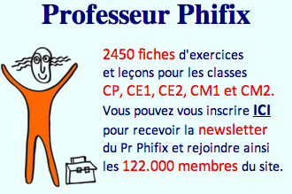  Lecture/ Decodage:  http://www.hatierpasapas.com/lecture/index.php
Sciences | Resources sorted by Big ideas  https://portal.sd71.bc.ca/group/wyhzgr4/Pages/default.aspx  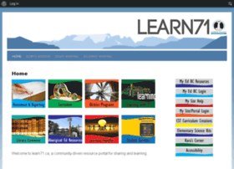  Resources sorted by learning content standard (PG SD#57:  http://prin.ent.sirsidynix.net/client/en_US/dlc/?rm=CURRICULUM+INS0%7C%7C%7C1%7C%7C%7C2%7C%7C%7Ctrue&dt=list

Sciences Humaines | Critical thinking challenges – English/ French  http://www.mysteryquests.ca/indexfr.html  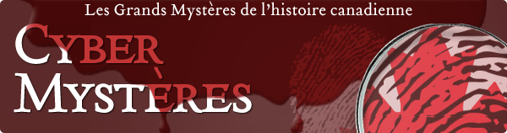  Francophonie explorations  http://www.laoujedors.ca/chambres  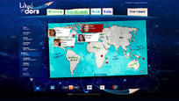  Explorations of Canada:  http://cabouge.tv5.ca/  Resources sorted by learning content standard (PG SD#57:  http://prin.ent.sirsidynix.net/client/en_US/dlc/?rm=CURRICULUM+INS0%7C%7C%7C1%7C%7C%7C2%7C%7C%7Ctrue&dt=list  Other websites: ERAC K12 Catalogue search by website:  https://k12.bcerac.ca/

Math | All programs – Staff programs – Math Worksheet Factory  National Library of Virtual Manipulatives (best to open with Internet Explorer)  http://nlvm.usu.edu/en/nav/vlibrary.html  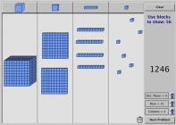  Khan Academy (math tutorials):  https://www.khanacademy.org/  Harcourt School ThinkMath! Interactive and step-wise explanations:  http://www.harcourtschool.com/thinkmath/index.html  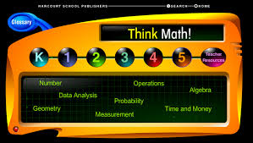  Matific  https://www.matific.com/ca/fr-ca/  Resources sorted by learning content standard (PG SD#57:  http://prin.ent.sirsidynix.net/client/en_US/dlc/?rm=CURRICULUM+INS0%7C%7C%7C1%7C%7C%7C2%7C%7C%7Ctrue&dt=list
Art | https://www.deepspacesparkle.com/ 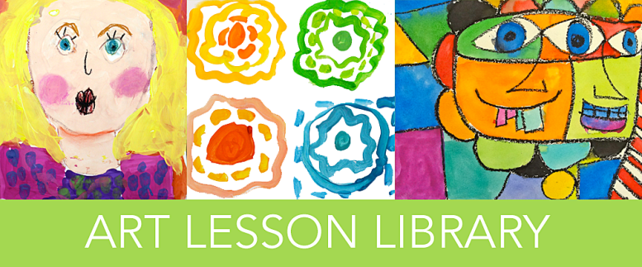  https://www.artsonia.com/
ADST | Coding:  https://code.org/  https://www.codecademy.com/  Digital Literacy  https://www.commonsense.org/education/scope-and-sequence
Multi-domain | Curriculum Wiki site of old BC Curriculum:  http://bccurriculum.pbworks.com/w/page/30099789/FrontPage  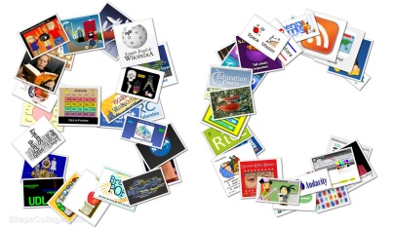  Gr 4/5 useful websites: http://45baker.weebly.com/liens.html  Resources sorted by learning content standard (PG SD#57:  http://prin.ent.sirsidynix.net/client/en_US/dlc/?rm=CURRICULUM+INS0%7C%7C%7C1%7C%7C%7C2%7C%7C%7Ctrue&dt=list  BrainPOP – video clips for Science, SH, Math & other subjects  https://fr.brainpop.com/  Discovery education video clips  http://www.discoveryeducation.ca/Canada/

